Neural Network Experiment-1

Name – Hemant Kumar

Roll.No.-24UADS1021

Objective
WAP to visualize the Perceptron Learning Algorithm using numpy and matplotlib/seaborn in Python. Evaluate performance of a single perceptron for NAND and XOR truth tables as input dataset

Code.py
import numpy as np
import pandas as pd
import matplotlib.pyplot as plt
import time
from sklearn.metrics import confusion_matrix, accuracy_score

class Perceptron:

def __init__(self, lr=1.0, epochs=6, sleep_time=1.0):
self.lr = lr
self.epochs = epochs
self.sleep_time = sleep_time

def step(self, z):
return 1 if z >= 0 else 0

#Decion Boundry Visualizer
def plot_boundary(self, ax, X, y, title):

ax.clear()
ax.set_title(title)

# plot points
for i in range(len(X)):
if y[i] == 1:
ax.scatter(X[i][0], X[i][1], marker="o", s=120, label="Class 1" if i==0 else "")
else:
ax.scatter(X[i][0], X[i][1], marker="x", s=120, label="Class 0" if i==0 else "")

# decision boundary w^T x = 0
# w0 + w1*x + w2*y = 0 -> y = -(b + w1*x)/w2
if self.w[2] != 0:
x_vals = np.array([-1,2])
y_vals = -(self.w[0] + self.w[1]*x_vals) / self.w[2]
ax.plot(x_vals, y_vals, 'k--', label="w^T x = 0")

ax.set_xlim(-0.5,1.5)
ax.set_ylim(-0.5,1.5)
ax.legend()

plt.draw()
plt.pause(0.01)

#Train Function

def fit(self, X, y, title="DATA"):

X_bias = np.c_[np.ones(X.shape[0]), X]
self.w = np.zeros(X_bias.shape[1])
losses = []

print("\n\n====== TRAINING ON", title, "======")

plt.ion()
fig, ax = plt.subplots()

for epoch in range(self.epochs):

print("\n====================================")
print(f"Epoch {epoch+1}")
print("====================================")

table_rows = []
error_count = 0

for i in range(len(X_bias)):

x = X_bias[i]
x1, x2 = X[i]
y_actual = y[i]

z = np.dot(self.w, x)
y_pred = self.step(z)

error = y_actual - y_pred

# update rule
self.w = self.w + self.lr * error * x

if error != 0:
error_count += 1

# Table Format
table_rows.append([
x1,
x2,
round(self.w[1],2),
round(self.w[2],2),
round(self.w[0],2),
y_actual,
y_pred
])

# animated decision boundry
self.plot_boundary(ax, X, y, f"{title} - Epoch {epoch+1}")
time.sleep(self.sleep_time)

losses.append(error_count)

df = pd.DataFrame(
table_rows,
columns=["x1","x2","w1","w2","b","y_actual","y_pred"]
)

print(df.to_string(index=False))

plt.ioff()
plt.show()

return losses

#Predict

def predict(self, X):
X_bias = np.c_[np.ones(X.shape[0]), X]
preds = []
for x in X_bias:
preds.append(self.step(np.dot(self.w,x)))
return np.array(preds)

#Datasets

X_nand = np.array([
[0,0],
[0,1],
[1,0],
[1,1]
])
y_nand = np.array([1,1,1,0])

X_xor = np.array([
[0,0],
[0,1],
[1,0],
[1,1]
])
y_xor = np.array([0,1,1,0])

#Loss Curve Function

def plot_loss(losses, title):
plt.figure()
plt.plot(losses, marker='o')
plt.title(f"Training Loss Curve - {title}")
plt.xlabel("Epoch")
plt.ylabel("Errors")
plt.show()

if __name__ == "__main__":

# ================= NAND =================
model1 = Perceptron(lr=1.0, epochs=6, sleep_time=1.0)
losses1 = model1.fit(X_nand, y_nand, title="NAND")

pred_train = model1.predict(X_nand)

print("\nConfusion Matrix (NAND):")
print(confusion_matrix(y_nand, pred_train))

print("Training Accuracy:", accuracy_score(y_nand, pred_train))

plot_loss(losses1, "NAND")

model2 = Perceptron(lr=1.0, epochs=6, sleep_time=1.0)
losses2 = model2.fit(X_xor, y_xor, title="XOR")

pred_train2 = model2.predict(X_xor)

print("\nConfusion Matrix (XOR):")
print(confusion_matrix(y_xor, pred_train2))

print("Training Accuracy:", accuracy_score(y_xor, pred_train2))

plot_loss(losses2, "XOR")

Output.txt

====== TRAINING ON NAND ======

====================================
Epoch 1
====================================
x1 x2 w1 w2 b y_actual y_pred
0 0 0.0 0.0 0.0 1 1
0 1 0.0 0.0 0.0 1 1
1 0 0.0 0.0 0.0 1 1
1 1 -1.0 -1.0 -1.0 0 1

====================================
Epoch 2
====================================
x1 x2 w1 w2 b y_actual y_pred
0 0 -1.0 -1.0 0.0 1 0
0 1 -1.0 0.0 1.0 1 0
1 0 -1.0 0.0 1.0 1 1
1 1 -2.0 -1.0 0.0 0 1

====================================
Epoch 3
====================================
x1 x2 w1 w2 b y_actual y_pred
0 0 -2.0 -1.0 0.0 1 1
0 1 -2.0 0.0 1.0 1 0
1 0 -1.0 0.0 2.0 1 0
1 1 -2.0 -1.0 1.0 0 1

====================================
Epoch 4
====================================
x1 x2 w1 w2 b y_actual y_pred
0 0 -2.0 -1.0 1.0 1 1
0 1 -2.0 -1.0 1.0 1 1
1 0 -1.0 -1.0 2.0 1 0
1 1 -2.0 -2.0 1.0 0 1

====================================
Epoch 5
====================================
x1 x2 w1 w2 b y_actual y_pred
0 0 -2.0 -2.0 1.0 1 1
0 1 -2.0 -1.0 2.0 1 0
1 0 -2.0 -1.0 2.0 1 1
1 1 -2.0 -1.0 2.0 0 0

====================================
Epoch 6
====================================
x1 x2 w1 w2 b y_actual y_pred
0 0 -2.0 -1.0 2.0 1 1
0 1 -2.0 -1.0 2.0 1 1
1 0 -2.0 -1.0 2.0 1 1
1 1 -2.0 -1.0 2.0 0 0

Confusion Matrix (NAND):
[[1 0]
[0 3]]
Training Accuracy: 1.0

====== TRAINING ON XOR ======

====================================
Epoch 1
====================================
x1 x2 w1 w2 b y_actual y_pred
0 0 0.0 0.0 -1.0 0 1
0 1 0.0 1.0 0.0 1 0
1 0 0.0 1.0 0.0 1 1
1 1 -1.0 0.0 -1.0 0 1

====================================
Epoch 2
====================================
x1 x2 w1 w2 b y_actual y_pred
0 0 -1.0 0.0 -1.0 0 0
0 1 -1.0 1.0 0.0 1 0
1 0 0.0 1.0 1.0 1 0
1 1 -1.0 0.0 0.0 0 1

====================================
Epoch 3
====================================
x1 x2 w1 w2 b y_actual y_pred
0 0 -1.0 0.0 -1.0 0 1
0 1 -1.0 1.0 0.0 1 0
1 0 0.0 1.0 1.0 1 0
1 1 -1.0 0.0 0.0 0 1

====================================
Epoch 4
====================================
x1 x2 w1 w2 b y_actual y_pred
0 0 -1.0 0.0 -1.0 0 1
0 1 -1.0 1.0 0.0 1 0
1 0 0.0 1.0 1.0 1 0
1 1 -1.0 0.0 0.0 0 1

====================================
Epoch 5
====================================
x1 x2 w1 w2 b y_actual y_pred
0 0 -1.0 0.0 -1.0 0 1
0 1 -1.0 1.0 0.0 1 0
1 0 0.0 1.0 1.0 1 0
1 1 -1.0 0.0 0.0 0 1

====================================
Epoch 6
====================================
x1 x2 w1 w2 b y_actual y_pred
0 0 -1.0 0.0 -1.0 0 1
0 1 -1.0 1.0 0.0 1 0
1 0 0.0 1.0 1.0 1 0
1 1 -1.0 0.0 0.0 0 1

Confusion Matrix (XOR):
[[1 1]
[1 1]]
Training Accuracy: 0.5

Hyperparameters
Learning Rate: 1.0
Epochs: 6
Activation Function: Step Function
Bias: Enabled
Weight Initialization: Zeros
Sleep Time (Animation): 1 second

Network Architecture
Input Layer: 2 neurons (x1, x2)
Bias Unit: 1
Output Layer: 1 neuron
Model Type: Single Layer Perceptron
Mathematical Decision Boundary: $w^{T}x=0$
Expanded Form: $b+w_{1}x_{1}+w_{2}x_{2}=0$
The model learns a linear decision boundary separating classes.

NAND OUPUT CURVES
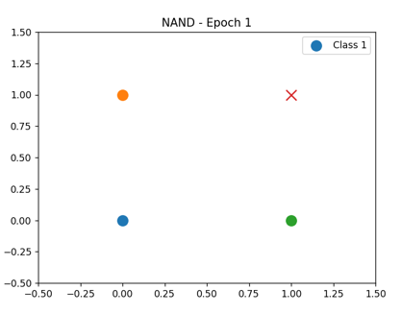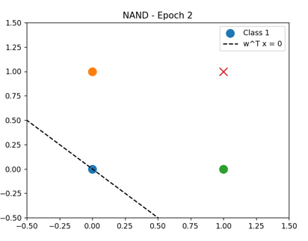
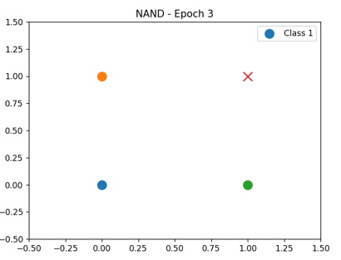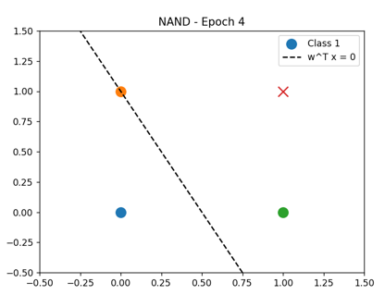
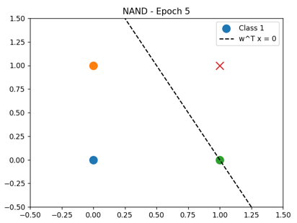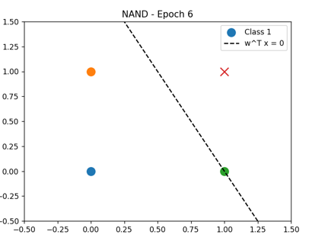

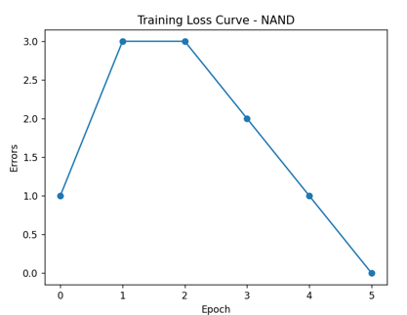

XOR OUTPUT CURVES
